CSA1515 CLOUD COMPUTING
Lab programs EXP :18-22
NAME: VIGNESHWAR.D
REG.NO: 192524415

18. Install Virtualbox/VMware Workstation with different flavours of linux or windows OS on top of your present windows environment.
Create two vms (ubuntu 26, ubuntu 24)
AIM:
To create Virtualbox/VMware Workstation with different flavours of linux or windows OS on top of your present windows
environment.
Create two vms (ubuntu 26, ubuntu 24)

IMAGE:
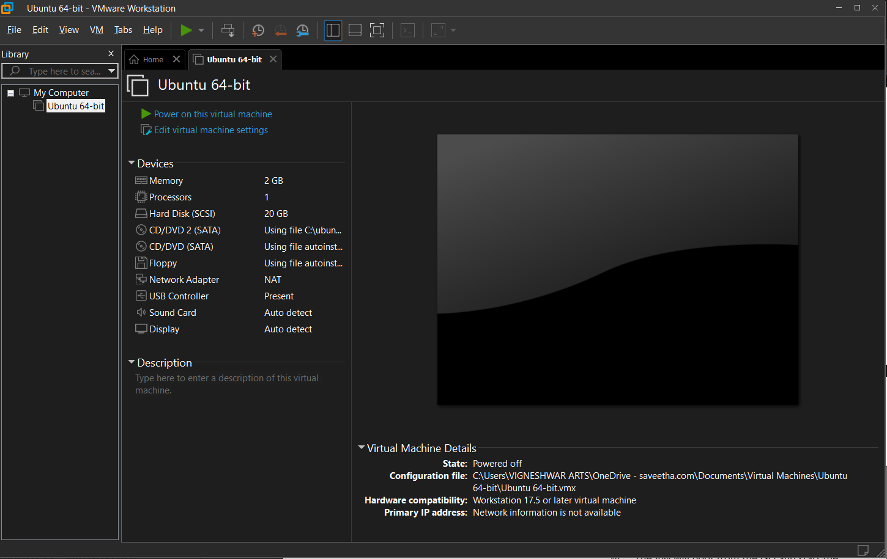

19. Install a C compiler in the virtual machine created using virtual box / VM Ware Workstation / Player and execute Simple C Programs.
AIM:
To Create and Install a C compiler in the virtual machine created using virtual box / VM Ware Workstation / Player and execute Simple C Programs.
IMAGE:
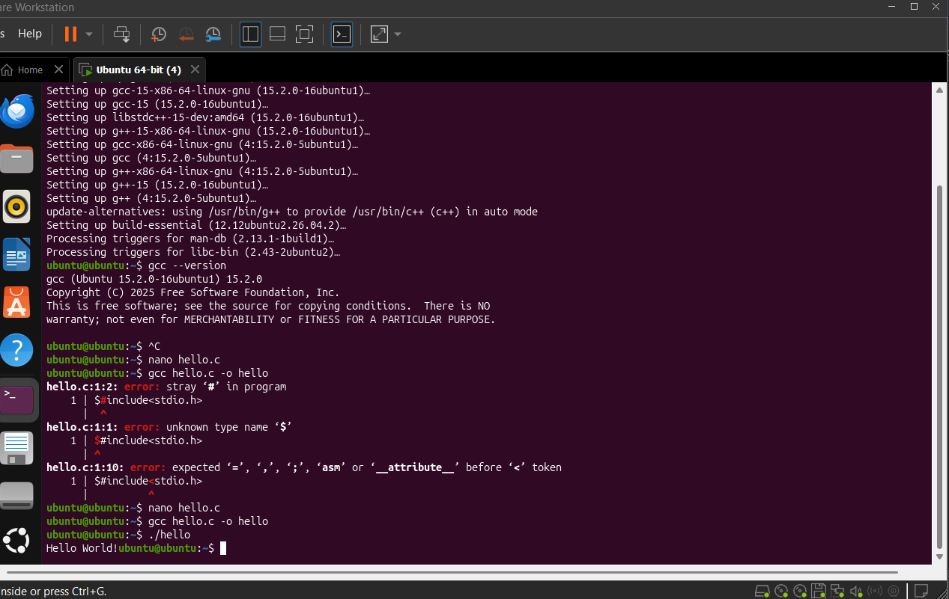

20 & 21. Install Virtualbox with different flavours of linux or windows OS on top of windows 10 using custom installation.

AIM:
To Install Virtualbox with different flavours of linux or windows OS on top of windows 10 using custom installation.

IMAGE:
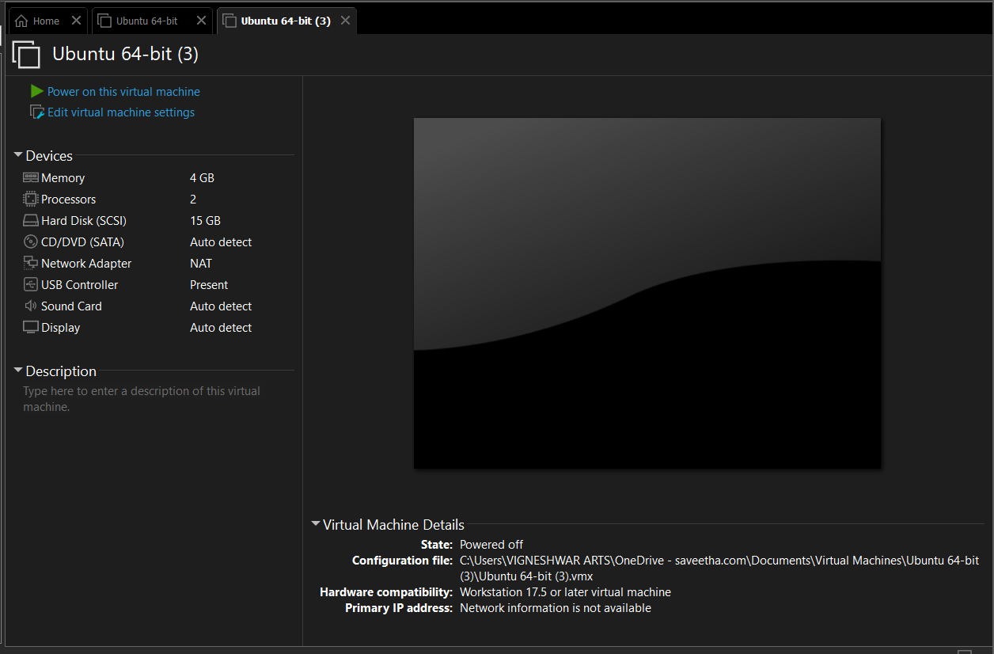

22. Create a Snapshot of a VM and Test it by loading the Previous
Version/Cloned VM.

AIM:
To Create a Snapshot of a VM and Test it by loading the Previous
Version/Cloned VM.

PROCEDURE:
• Open VMware Workstation.
• Start your Virtual Machine and make sure the guest OS is
working.
• Create a Snapshot
• Go to VM → Snapshot → Take Snapshot.
• Enter a name, e.g., Before Changes.
• Click Take Snapshot.
• Make Changes to the VM
• Create a new folder/file.
• Install a small application or change a setting.
• This represents changes made after the snapshot.
• Test the Snapshot
• Go to VM → Snapshot → Snapshot Manager.
• Select Before Changes.
• Click Go To / Restore.
• Confirm the Previous State
• Start or restart the VM if required.
• Check whether the changes made after the snapshot
have been removed.

IMAGE:
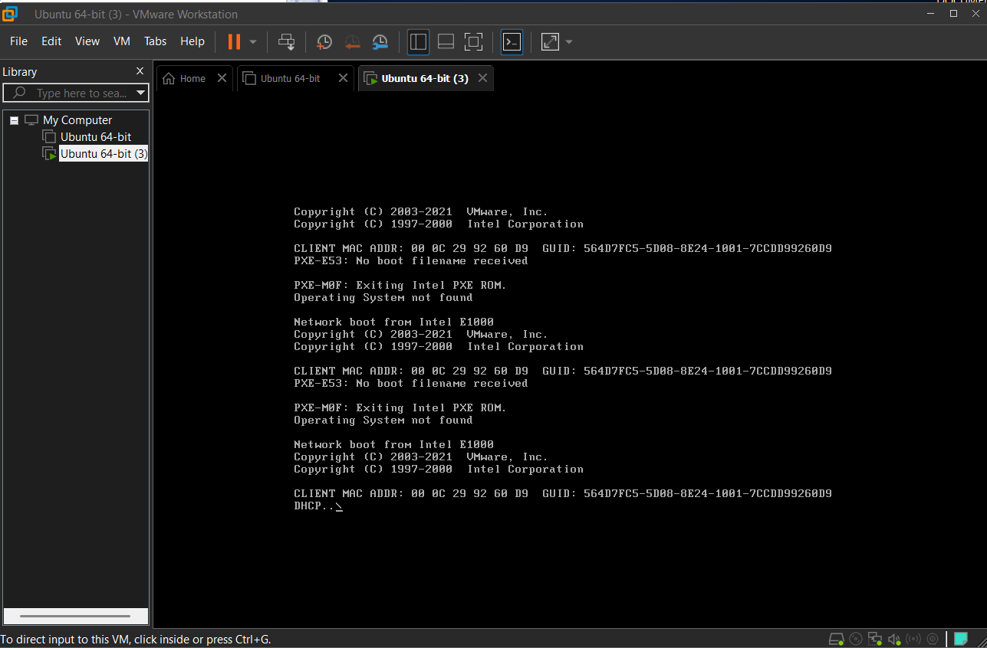

23. Create a Cloning of a VM and Test it by loading the Previous
Version/Cloned VM

AIM:
To Create a Cloning of a VM and Test it by loading the Previous
Version/Cloned VM

PROCEDURE:
Clone the VM
1. Power off the VM.
2. Go to VM → Manage → Clone.
3. Select the snapshot as the cloning point.
4. Choose Create a Full Clone.
5. Give the cloned VM a new name.
6. Click Finish.
7. Start the cloned VM and verify that it contains the previous
VM state.

IMAGE:
